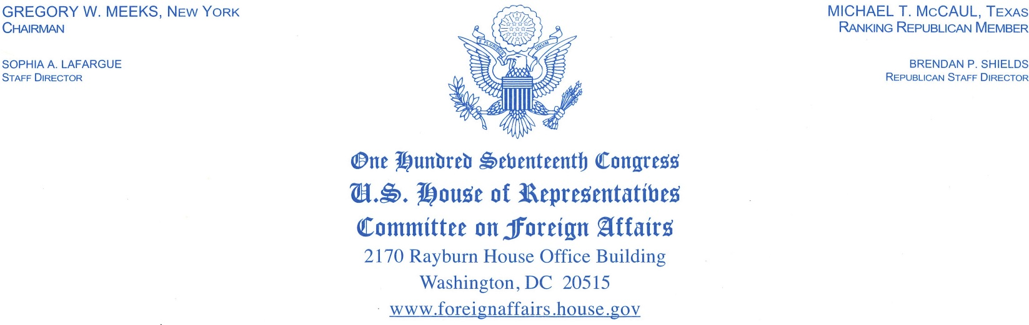

Parag Agrawal
Chief Executive Officer
Twitter
1355 Market Street, Suite 900
San Francisco, CA 94103

Dear Mr. Parag Agrawal:

I write to express great concern about the Iranian regime’s use of your social media platform to send threatening messages towards U.S. public officials, including former Secretary of State Mike Pompeo. On June 17, 2022, a Twitter account identified as belonging to Zainab Soleimani tweeted that former Secretary Pompeo should “Live in Fear”. The text was accompanied by a picture of former Secretary Pompeo in a cage, with the previous quote written in what resembles blood. The account and tweet remain public. Another tweet published on June 19, 2022, from an account affiliated with the Iranian regime stated that Secretary Pompeo should “live in fear”. The tweet also included a picture of Pompeo with a firearm scope trained on his head. The tweet was deleted, but the account is currently public.
According to Twitter’s violent threats policy, content “may not threaten violence against an individual or a group of people. [Twitter] also prohibit[s] the glorification of violence.” Going further, Twitter claims that it “will immediately and permanently suspend any account found to be posting violent threats”. According to Twitter’s abusive behavior policy page, the company does “not tolerate content that wishes, hopes, promotes, incites, or expresses a desire for death, serious bodily harm or serious disease against an individual or group of people... Violent threats are declarative statements of intent to inflict injuries that would result in serious and lasting bodily harm”. In the case of the June 19 tweet, this prohibition would apply to the image of former Secretary Pompeo that has a firearm scope superimposed on his head, since the image conveys the idea that he will or should be targeted by violent means.
Twitter’s abusive behavior policy makes clear that direct threats against an identifiable target, such as former Secretary Pompeo, are completely out of bounds. Users who violate such rules should be permanently banned under your company’s zero-tolerance policy: “We prohibit content that makes violent threats against an identifiable target… We have a zero tolerance policy against violent threats. Those deemed to be sharing violent threats will face immediate and permanent suspension of their account… We prohibit behavior that encourages others to harass or target specific individuals or groups with abusive behavior.” The aforementioned tweets clearly violate Twitter’s terms of service. Both accounts should be banned from the platform for threats made against former Secretary Pompeo. Twitter must not be a platform from which violence can be incited, and central to this is consistency in enforcement of Twitter’s rules.
At your earliest convenience, please transmit in writing what your official stance is regarding the threats to U.S. officials, including Secretary Pompeo, that are made over your platform. In addition, please confirm that the content flagged above will be deleted, and that relevant users will be permanently suspended from Twitter. If you choose not to take these steps, please convey in writing your official rationale for inaction.
I look forward to your reply.
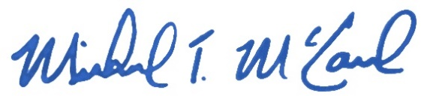
Best regards,

___________________________
Michael T. McCaul
Ranking Member
House Foreign Affairs Committee

Ronn Blitzer, “Iran Again Threatens to Assassinate Pompeo: 'Live in Fear',” Fox News (FOX News Network, June 22, 2022), https://www.foxnews.com/politics/iran-again-threatens-assassinate-pompeo-live-fear.
Adam Kredo, “Iran Renews Threats to Assassinate Secretary of State Pompeo,” Washington Free Beacon, June 21, 2022, https://freebeacon.com/national-security/iran-renews-threats-to-assassinate-mike-pompeo/.
https://help.twitter.com/en/rules-and-policies/violent-threats-glorification
https://help.twitter.com/en/rules-and-policies/abusive-behavior
https://help.twitter.com/en/rules-and-policies/abusive-behavior

